Aim of the Practical
To understand the basic structure of a PL/SQL program by creating and executing a simple PL/SQL block that includes declaration and execution sections, and to display output using built-in procedures.

Tool Used
Database Management System
- Oracle Database
Database Administration Tool
- Oracle SQL*Plus / SQL Developer

Objective
- To create a simple PL/SQL program demonstrating the Declaration Section and Execution Section.
- To declare and initialize variables in a PL/SQL block.
- To display output using DBMS_OUTPUT.PUT_LINE.
- To perform basic mathematical calculations in PL/SQL.

Practical / Experimental Steps
- Open Oracle SQL*Plus or Oracle SQL Developer.
- Create a new SQL worksheet.
- Enable output display using the command:
- SET SERVEROUTPUT ON
- Write a PL/SQL block with a DECLARE section to define employee details.
- Use the BEGIN...END block to perform calculations.
- Display the employee details and calculated bonus using DBMS_OUTPUT.PUT_LINE.
- Execute the program and verify the output in the output window.

I / O Analysis
PL/SQL Block: Employee Details and Bonus Calculation
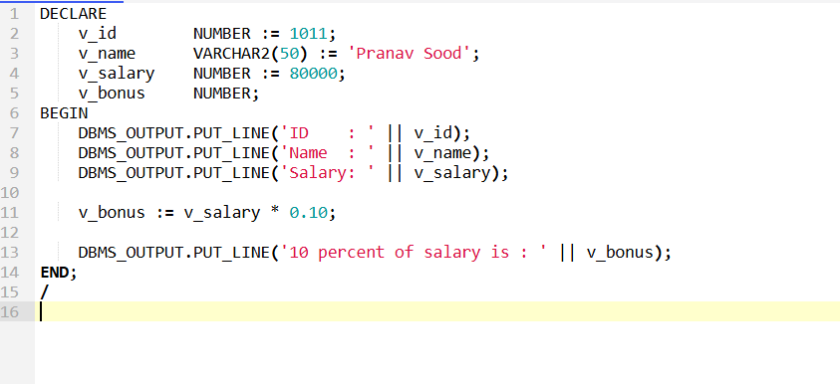

Output
- Displays Employee ID, Name, and Salary
- Calculates 10% bonus of the salary
- Displays the calculated bonus amount
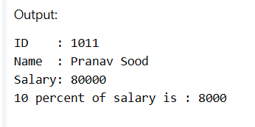

Learning Outcomes
- Understood the basic structure of a PL/SQL block including DECLARE and BEGIN...END.
- Learned how to declare and initialize variables in PL/SQL.
- Practiced using DBMS_OUTPUT.PUT_LINE for displaying program output.
- Performed arithmetic operations on numeric variables.
- Gained confidence in writing and executing simple PL/SQL programs.

